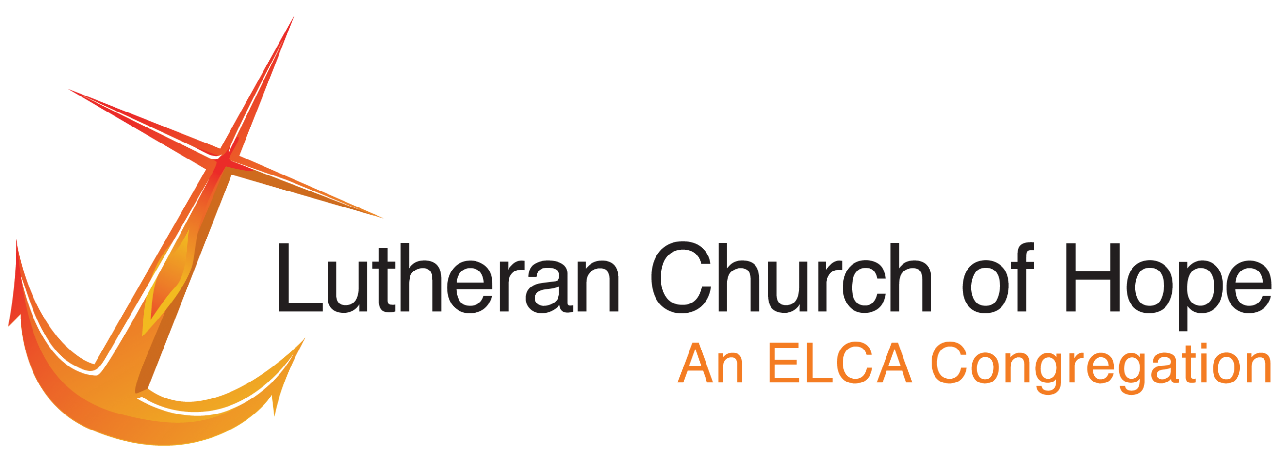

BRAND

GUIDELINES

established 2017

Sharing and Transforming faith, hopes, and lives. www.lchope.org

Updated 10.9.20
TABLE OF CONTENTS

Introduction Page 3

Our Brand Page 4

Logo Basics Page 6

Coloring Page 7

Logo Identity Usage Page 8

Typography Page 10

Print Media Page 12

Digital Media Page 13

Voice and Writing Style Page 14

Imagery Page 15

Importance of an Identity
INTRODUCTION

Lutheran Church of Hope, located at 1305 West 10th Avenue in Broomfield, is an ELCA congregation serving Broomfield since 1963. LCHope means different things to different people. To many, it is a home away from home, a place to relax with the comfort of old friends. To others, it is a place to serve the Lord as a worship assistant, or to give back to the community through Feed the Homeless ministry. It is a meeting place for Sunday morning worship and Wednesday night fellowship. It is a place of learning, loving, caring, and healing.

While Lutheran Church of Hope might be defined differently depending on who you ask, its brand is the one thing that stays the same, that combines everything that LCHope is into one identity. Our brand defines who we are, our mission, our vision, our reputation, our personality. As a growing church in the Broomfield community, it is essential that we communicate a consistent, high-quality image.

This brand guide helps ensure all tenets and ministries of the church are working together to communicate with a unified image and voice in LCHope. Our reputation is informed primarily by what we do but it is also influenced by what and how we communicate. This document provides general guidelines for the visual and verbal articulation of the LCHope brand, as well as specific direction for the application of our logo and related elements. By working together, we can ensure we remain recognized and trusted by the Broomfield community and beyond.

Note: It should be noted that the elements and uses in this guide are subject to change; however, these changes will be reviewed and assessed periodically to ensure there is always a single standard usage overall.

Lutheran Church of Hope: Mission
OUR BRAND

Lutheran Church of Hope proclaims Jesus Christ as Lord and Savior by:
worshiping together,
making disciples of all,
reaching out to spread God’s word, and
providing loving support to all.

Lutheran Church of Hope: Vision Statement

Sharing and Transforming faith, hopes, and lives.

Who are we?

Who are we? Our brand is a powerful tool that helps define this question – not only to our staff and members, but to volunteers, partners, supporters and the general public. Our logo, typefaces, and color guidelines have been carefully selected to reflect the qualities that bring LCHope together as a church.

As an active church in the Broomfield community, we serve an endless number of people through our outreach ministries; engage family and friends through ever-growing worship, music, and discipleship ministries; and provide a sense of belonging for our members through loving support ministries.

We are a church with generations of members who grew up in the Lutheran tradition and with brand new visitors who have never gone to church before. Our worship liturgy is based on tradition, with a few modern updates. We are a church full of people who love LCHope not only because of the religion it provides but because of the friends they’ve made, the activities they can participate in, and the things they learn.

The keywords most often associated with LCHope include:

Family
Music
Community Outreach
Hope

Our brand personality reflects a welcoming, open, engaged, and innovative church family that consistently hopes for the future, hopes to engage and serve the greater community, hopes to support one another in all we do, and hopes to be a compassionate, nurturing, respected church for one and all. It is this hope that binds us together.

Our brand also follows the brand guidelines of the Evangelical Lutheran Church in America (ELCA), of which LCHope is a part. Brandmark usage for the ELCA can be found online at www.elca.org/Resources/ELCA-Branding. LCHope agrees with the values established by the ELCA. The ELCA brandmark should be used on official documents. According to the ELCA’s document, Building Awareness of Our Church, “We’re all part of the same church. Whether you’re communicating about or promoting the ministries of a congregation, synod or sub-brand, it’s important to convey a strong visual connection to the ELCA — doing so underscores our strength as a faith community and our shared sense of purpose.”

The Basics of the LCHope Logo
LOGO BASICS

“We have this Hope, a sure and steadfast anchor of the soul.”
-Hebrews 6:19a
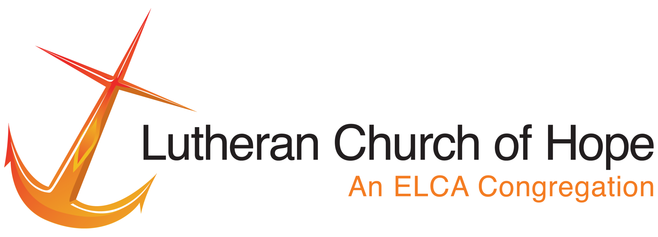

Our logo was created by Ms. Michele Garner. It is similar in style to the brandmark of the ELCA.

The main logo always consists of the anchor (our emblem) on the left, with text on the right. The emblem is a graphic representation of our vision and mission statements, and the Bible verse (above) that we follow every day.

The logo is never surrounded by an outline. The anchor is always orange, and the text should never be changed except for special church campaigns as approved by the communications minister and pastor. Never attempt to recreate the logo – always use the artwork provided and adhere to the usage guidelines. Don’t change the typeface, colors, or elements of the logo. Don’t stretch, squeeze or smash it. Don’t bedazzle, bespeckle or bejewel it. This is how the logo should look on all outgoing correspondence, including email signatures, printed letters, and website.

Sizing should always be in a ratio of 1.8:5 height:width.

The font used in the logo is Helvetica. The font should not be altered in any way.

The secondary logo is simply the anchor, without text. This logo is to be used on materials where the text would be redundant or aesthetically displeasing.

Either the main logo or the secondary logo should be used on all printed materials and digital advertisements for the church. The logo should never not be seen.
Colors – Main Logo
COLORING

TEXT: RGB: 34, 30, 31 RGB: 255, 94, 5 CMYK: 70, 68, 64, 75 CMYK: 0, 63, 98, 0 Hex: #221E1F Hex: #F47C22

ANCHOR RGB: 252, 8, 13 RGB: 233, 181, 47
CMYK: 1, 97, 95, 0 CMYK: 5, 27, 98, 0
Hex: #FC080D Hex: #E9B52F

Secondary Colors

These colors may be used as a decorative border or accent color in advertisements, brochures or special publications.

RGB: 255, 94, 5
CMYK: 0, 63, 98, 0
Hex: #FF5E05

RGB: 6, 46, 70
CMYK: 74, 71, 64, 87
Hex: # 062E46

RGB: 34, 103, 66
CMYK: 85, 30, 86, 23
Hex: # 226742

Reformatting
LOGO IDENTITY USAGE

The LCHope logo can be reformatted in three ways:

Horizontal, white lettering:
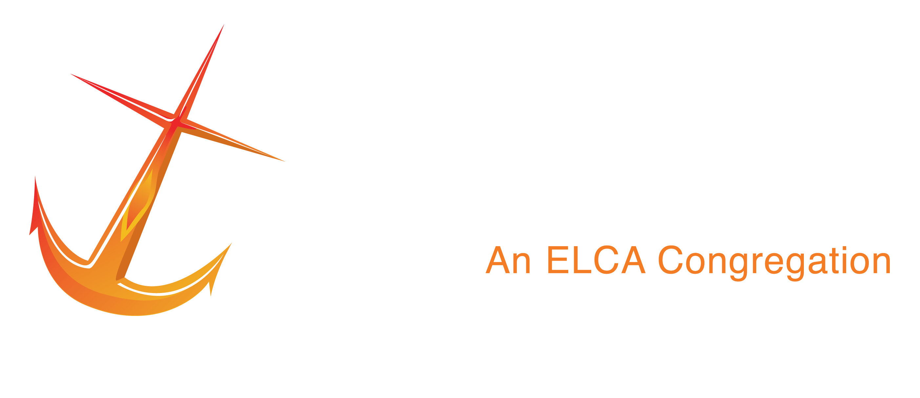

For use on black or dark backgrounds.

 | Anchor Only, color: | Anchor Only, b+w:
For use when text is redundant |  | For use when text is redundant and color is in black and white

The following examples are unacceptable reproductions of the LCHope logo:

The logo should never have an outline or border.

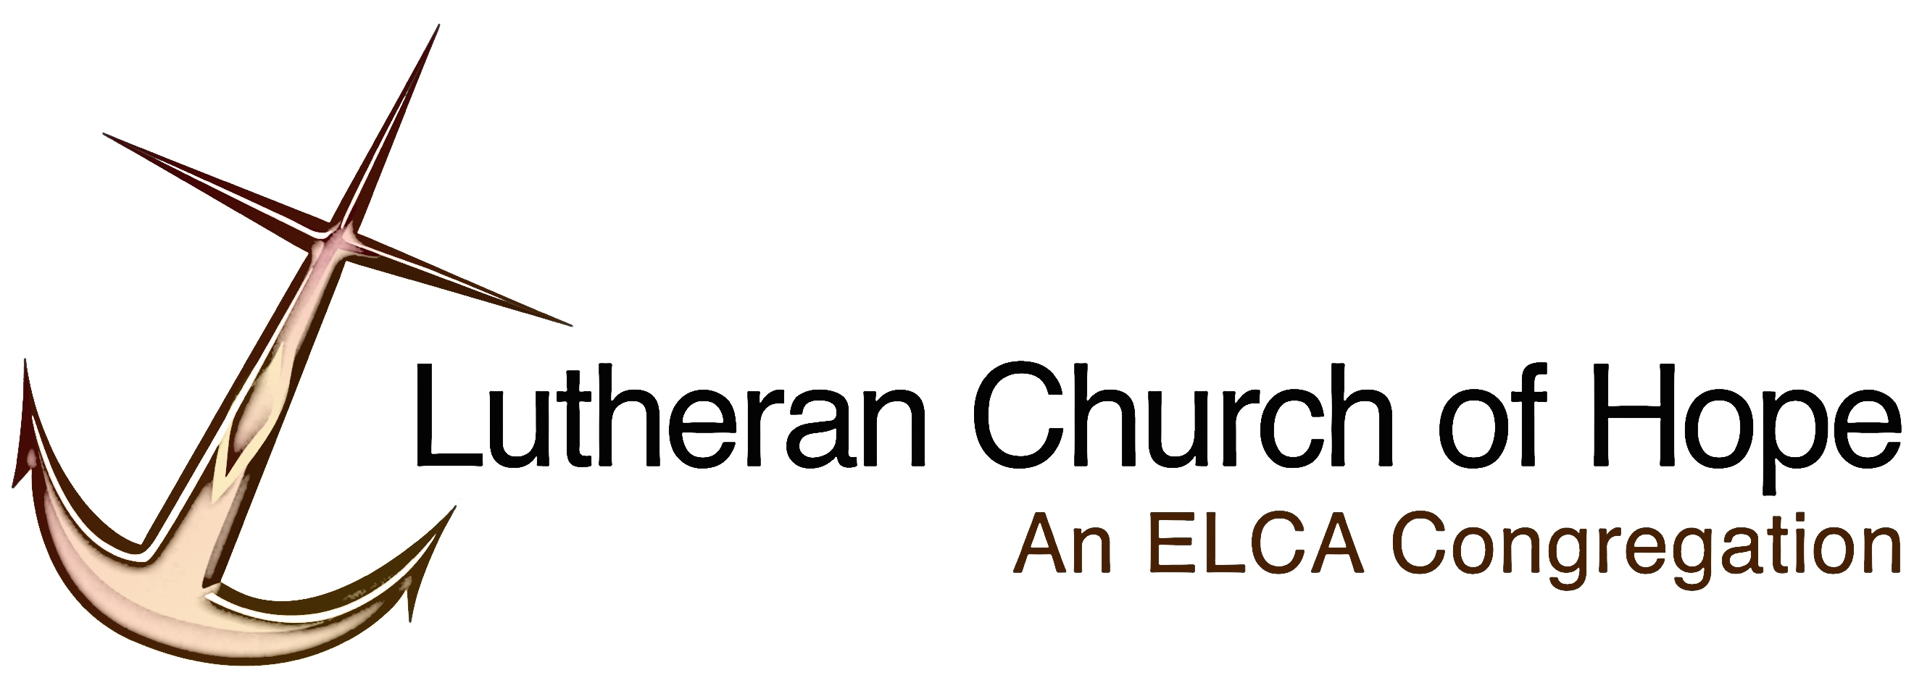

No artistic effects should be placed on the logo.

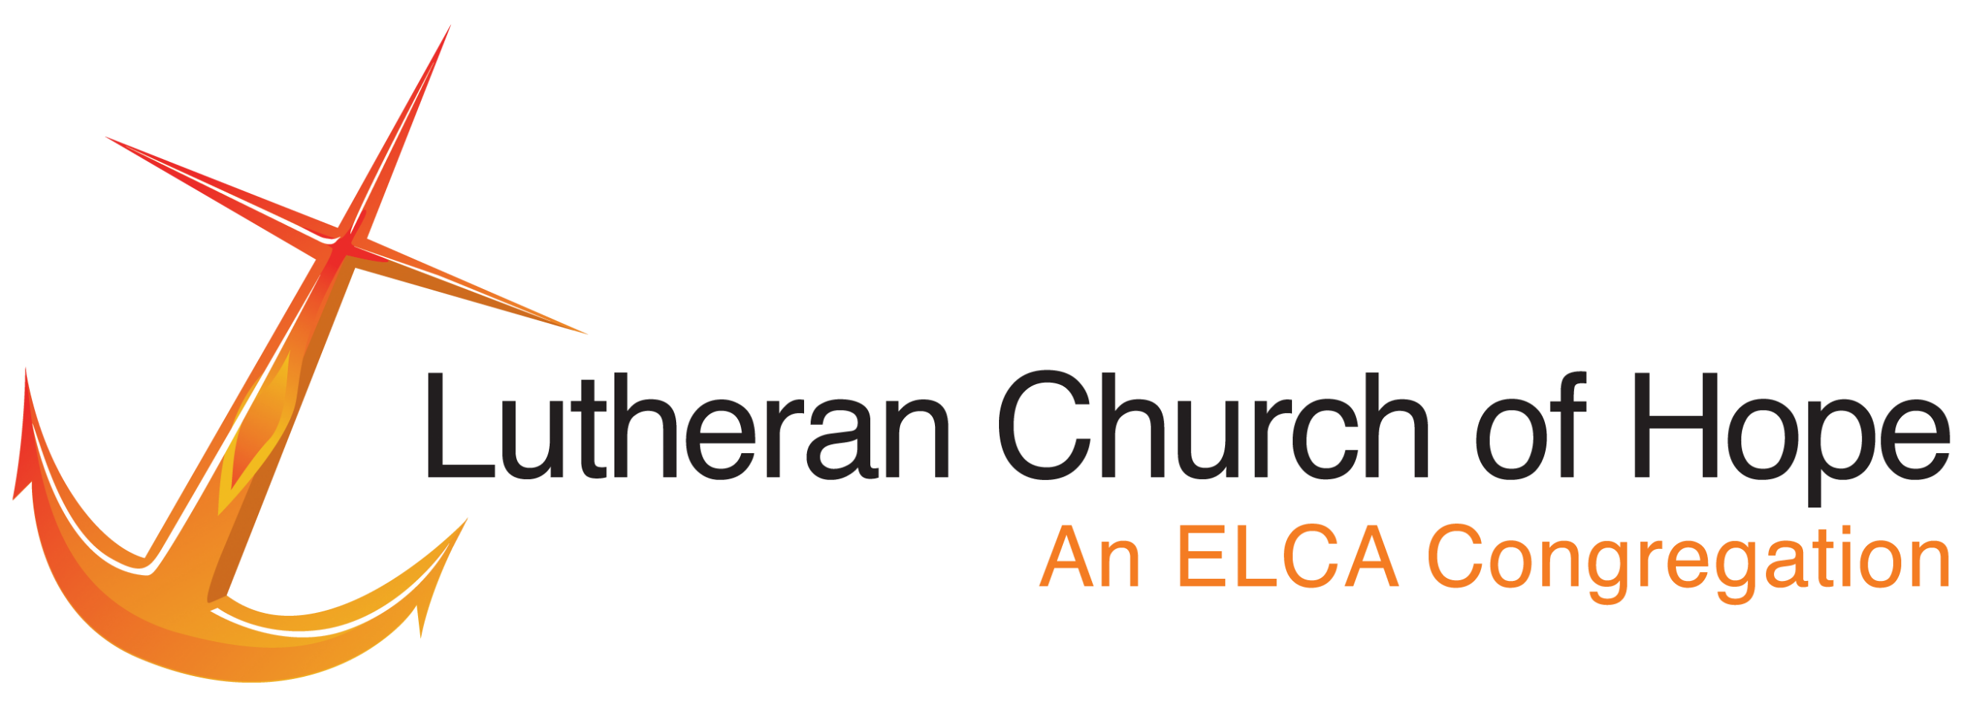
The logo should always maintain the same ratio.

The anchor point should always be facing right. | The logo should always maintain the same colors.

Logo
TYPOGRAPHY

The font used in the logo is Helvetica and should not be altered in any way.

Print

For printed materials, including letters, envelopes, brochures, flyers and posters, the following fonts are used, both for their versatility and availability:

Helvetica, Arial, Book Antiqua

Helvetica is the primary font, to be used mainly for headlines. A bold, clean, modern font, Helvetica is also the font used in our logo.

Arial is a secondary font, which can be used as a headline or subheadline, and may be used as main type when the writing is less formal (i.e. eAnchor newsletter). It is nearly identical to Helvetica, with a few differences.

Book Antiqua is the primary supporting typeface of LCHope. It may be used for subheads and primary body copy on formal, official documents (such as typed letters, bulletins, and reports), and it can also be used for headlines in conjunction with the Helvetica typeface. Book Antiqua is a serif font, easy to read in print, a font that is reflective of tradition.

Other fonts may be used for less formal projects, such as for children’s advertisements. Fonts such as Edwardian Script are acceptable on rare instances for special worship bulletin covers. All font choices should be approved by the communications minister before use.

HELVETICA ABCDEFGHIJKLMNOPQRSTUVWXYZ
Headline abcdefghijklmnopqrstuvqxyz
1234567890!@#$%^&*();’:”[]{},.<>?

Bold italic regular

ARIAL ABCDEFGHIJKLMNOPQRSTUVWXYZ
Headline abcdefghijklmnopqrstuvwxyz
Subheadline 1234567890!@#$%^&*();’:”[]{},.<>?

Bold italic regular

BOOK ANTIQUA ABCDEFGHIJKLMNOPQRSTUVWXYZ
Main Body abcdefghijklmnopqrstuvqxyz
1234567890!@#$%^&*();’:”[]{},.<>?

Bold italic regular

Digital

For digital materials, including the website, blogs, and made-for-web posters and flyers, the following fonts are used:

Helvetica is an acceptable font for digital publications, both as headline and main body. Arial is also an acceptable replacement for digital. Serif fonts (such as Georgia) are more acceptable in digital form as headers instead of body.

HELVETICA ABCDEFGHIJKLMNOPQRSTUVWXYZ
abcdefghijklmnopqrstuvwxyz
1234567890!@#$%^&*();’:”[]{},.<>?

Bold italic regular

GEORGIA ABCDEFGHIJKLMNOPQRSTUVWXYZ
abcdefghijklmnopqrstuvqxyz
1234567890!@#$%^&*();’:”[]{},.<>?

Bold italic regular
Examples of Correct Logo Usage
PRINT MEDIA

Letterhead with logo at bottom right, secondary logo at center, office information at bottom left in Helvetica font, with body to be written in Book Antiqua.
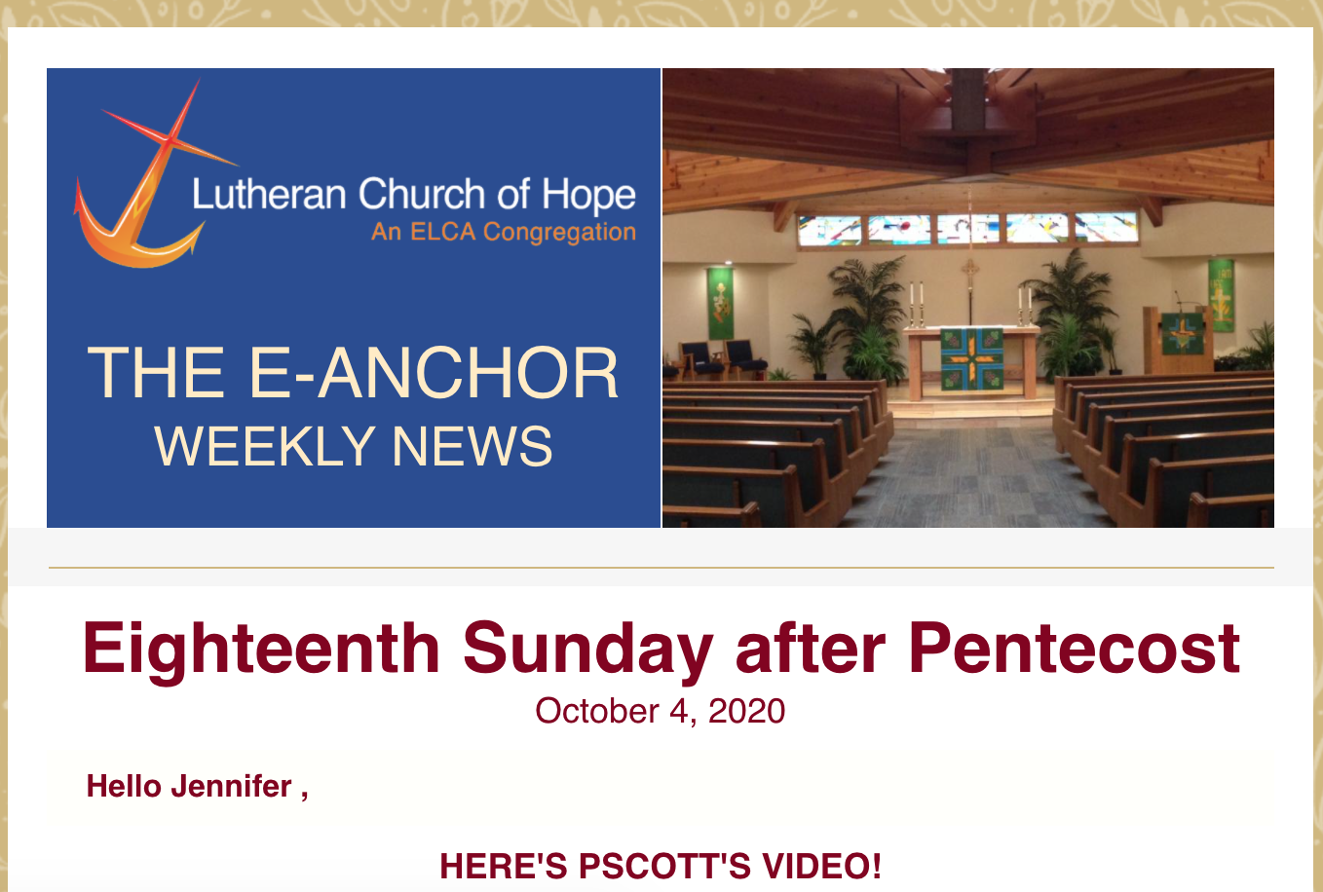
DIGITAL MEDIA

E-Anchor sample with Helvetica headline and body

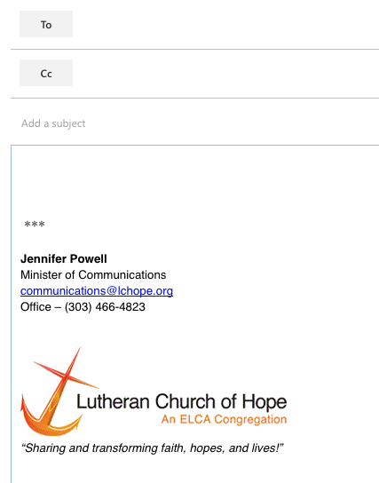

Email signature with Helvetica font
All LCHope communications should portray excellence and openness, reinforcing that we are a welcoming, engaging church.
VOICE AND WRITING STYLE

Use of “insider” terms and obscure or confusing religious terms should be avoided in all community announcements and advertisements that extend beyond the church (i.e. Our Broomfield magazine announcements, special advertisements or brochures). Such terms could include “tenet,” “discipleship,” or “love offering.”

Identifying the Church Name

In formal communications, the first reference to the church should always use its full name, “Lutheran Church of Hope.” Any subsequent references can use “LCHope.” Please do not use LCH as an acronym, as our goal is for outsiders to get to know who we are.

The Voice of LCHope

LCHope is a personable, friendly church, fun, engaging, accessible to all. Our speaking and writing style should reflect that.

Be simple and clear.

With every piece of content we publish, we aim to:

Educate. Whether it is a Bible Study, a financial analysis, or a youth trip recap, the content we publish should inform church members and the community alike on LCHope, its beliefs, and activities.

Empower. Help people understand LCHope by using language that informs them and encourages them to get involved.

Inspire. LCHope is sharing and transforming faith, hopes, and lives – we live to inspire that vision in ourselves and in others.

In order to achieve those goals, we make sure our content is:

Clear. Use simple words and sentences. Don’t use insider language for outsider articles.

Useful. Before you start writing, ask yourself: What purpose does this serve? Who is going to read it? What do they need to know?

Friendly. Write like you are speaking with another church member.
Photography
IMAGERY

LCHope is an active church that supports its members in worship and fellowship, and supports the community through outreach opportunities. The photographs we display on our website, in print, and through social media, should reflect the welcoming attitude of our congregation, and indicate the diverse opportunities we offer to both our members and the community at large.

Photos are accepted from staff, church members, and friends, and should be sent to photos@lchope.org. All photos are to be stored in an online database on flickr.com.

Acceptable photos should fall under the four LCHope brand buzzwords:

Family

Music

Community Outreach

Hope

Family photos include generational photos, church family and friends, people smiling, children, and other active shots. Portrait shots of members are especially useful.

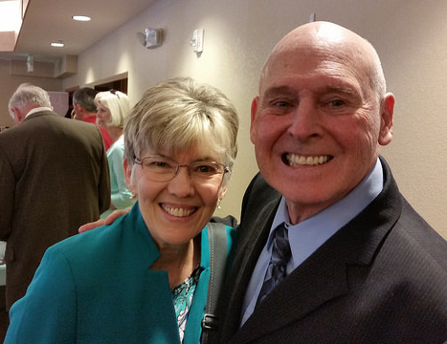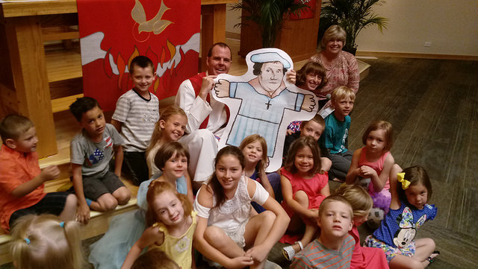

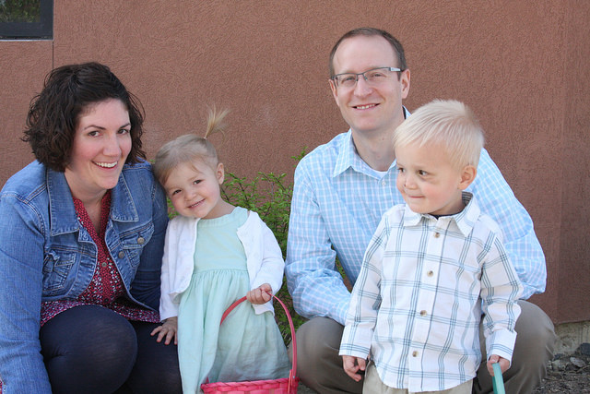
Music photos include both images of our instruments and people singing and performing. Photos should show off our eclectic music ministries, from choir and handbells to tone chimes and instrumentals like the flute, saxophone, and even cowbells and djembe.

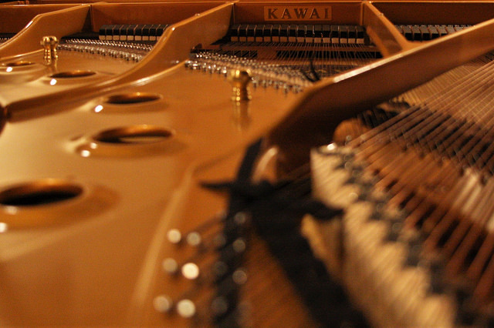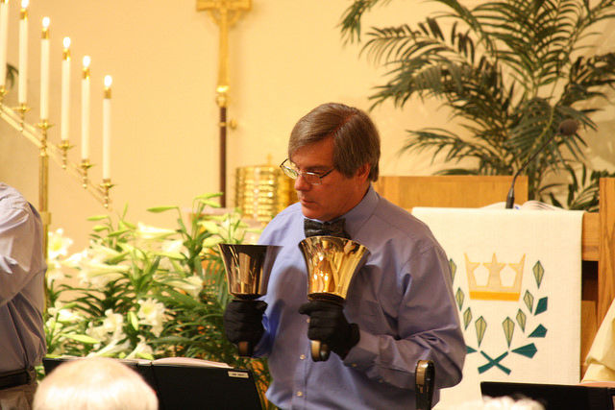

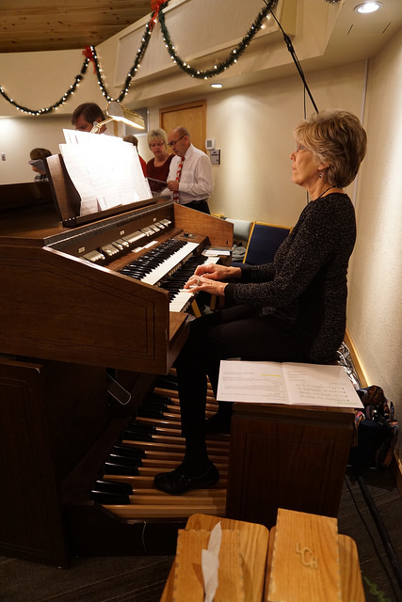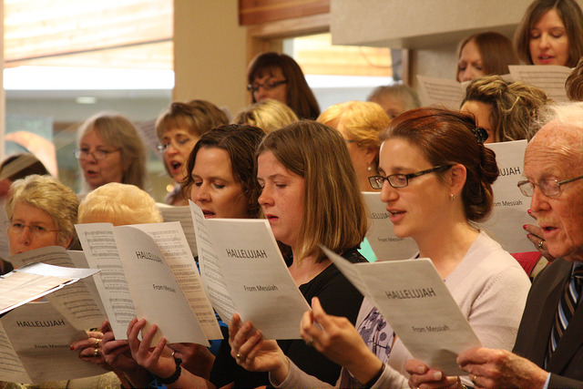

Community Outreach photos are images of LCHope’s major outreach ministries and donations – clothing and food donations, Oktobeerfest, Feed the Homeless, or other events are acceptable, whether taking place within church walls or without. The clearer the image, the better.

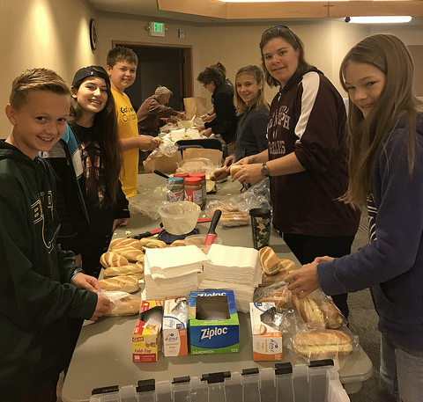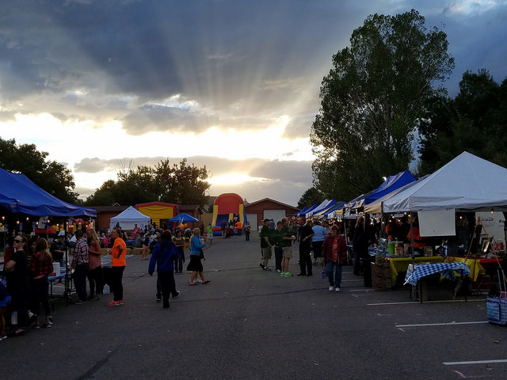

Hope photos can include images of the church building itself, worship services, and general images that show LCHope at its best!

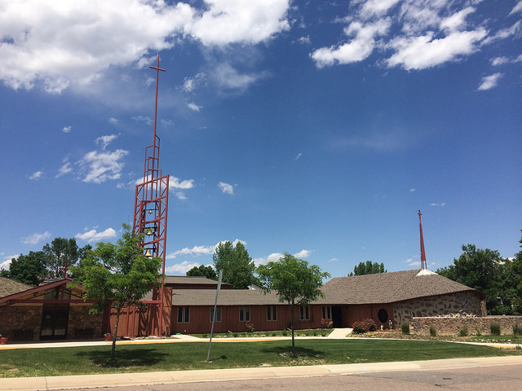

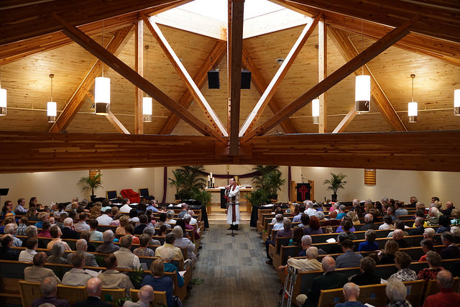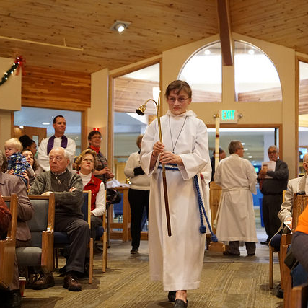

Best Practices

DO use candid, authentic imagery.

DO showcase LCHope’s members’ diversity in age, gender, race, and background.

DO use imagery that makes LCHope opportunities look engaging, faithful, and fun.

DO encourage members and friends to take photos on their own and submit them to photos@lchope.org for church publication use.

DO get permission before using any non-staff photos, photos taken from social media, or photos not sent directly to the church office.

DO follow ELCA brand photography guidelines by “providing a visual articulation of our faith: how we pray and celebrate, how we interact with one another, and what it means to us and the people we serve when we use our hands to do God’s work in the world.”

DO correctly attribute all photos.

